Nardos Gebremedhin
Module 5.2
CSD 380
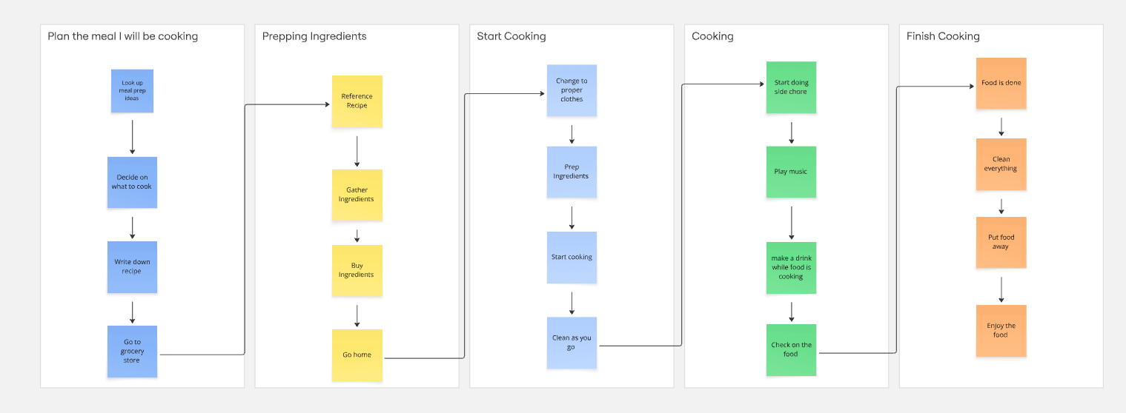
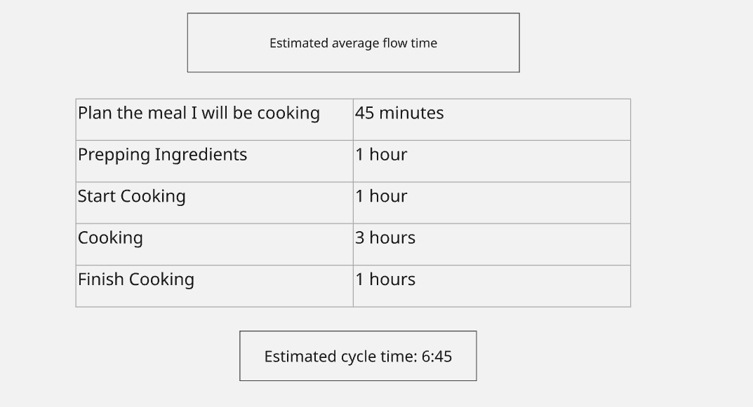

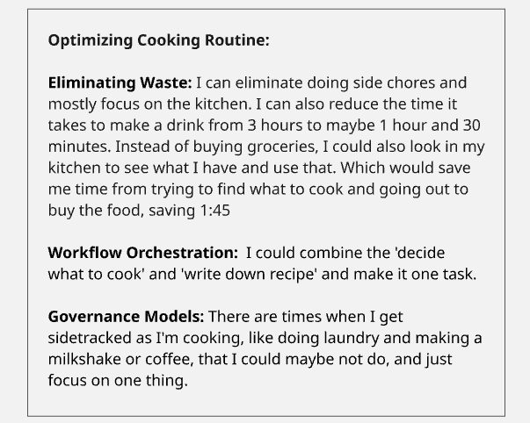

I was able to use Miro, but when I downloaded it as a PDF, it only grabbed the VSM, and when I downloaded it as an image, it only had a small option, so I just screenshotted it.

